PROJECT REPORT



SUBMITTED BY :- SUBMITTED TO:-

LAKSHMI SAI SRIKAR VADLAMANI PROF. AJAY

(2K19/CO/208)

JAYANT RANA

(2K19/CO/177)

**TURING MACHINE SIMULATION**

**Introduction**

A Turing Machine (TM) is a mathematical model which consists of an infinite length tape divided into cells on which input is given. It consists of a head which reads the input tape. A state register stores the state of the Turing machine. After reading an input symbol, it is replaced with another symbol, its internal state is changed, and it moves from one cell to the right or left. If the TM reaches the final state, the input string is accepted, otherwise rejected.

* A TM can be formally described as a 7-tuple (Q, X, ∑, δ, q0, B, F) where −
* **Q** is a finite set of states
* **X** is the tape alphabet
* **∑** is the input alphabet
* **δ** is a transition function; δ : Q × X → Q × X × {Left_shift, Right_shift}.
* **q0** is the initial state
* **B** is the blank symbol
* **F** is the set of final states

A Turing machines consists of three parts:

1. A tape.
2. A write head
3. A machine state.

The tape is divided into a sequence of squares, each of which may store a single character belonging to a given character set.

**Algorithm**

Start

* Initially we start off at state q1, and store it.
* We move the tape head until the end of the string and look for the 0. We store the final letter and compare it to the letter found at the start at q1.
* If they are equal, the first letter is updated to 0 and we go to state q2, i.e successful comparison and the iteration starts again.
* If unequal we go to state rn, and the program terminates with output, NOT PALINDROME.

End

**Diagram**

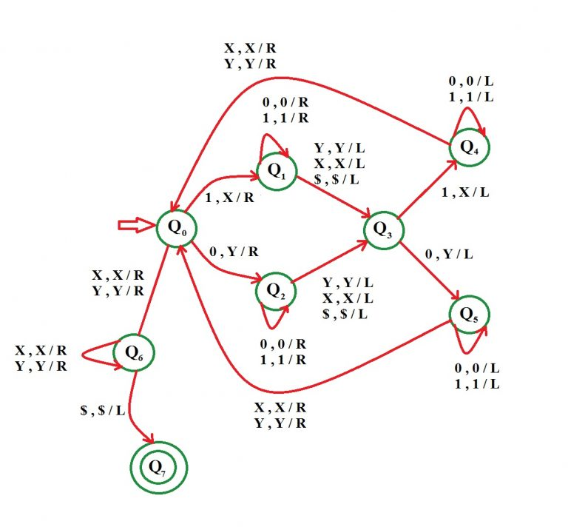

**Output Screenshots and Explanation**

**PALINDROME**

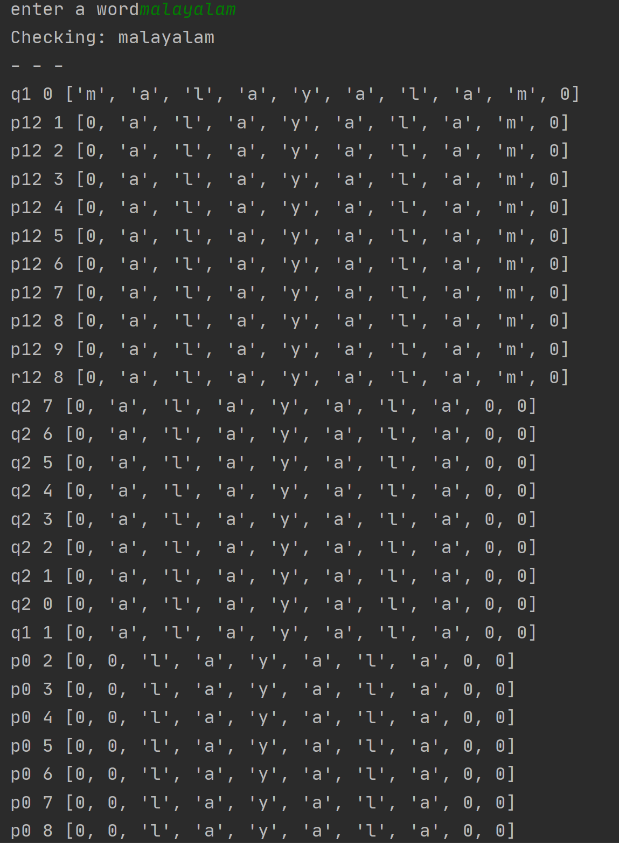

We can see that tape head starts off at q1 and moves right until it hits 0 and once it does it compares it to the character encountered at first. These steps continue until all letters of string are updated to 0.

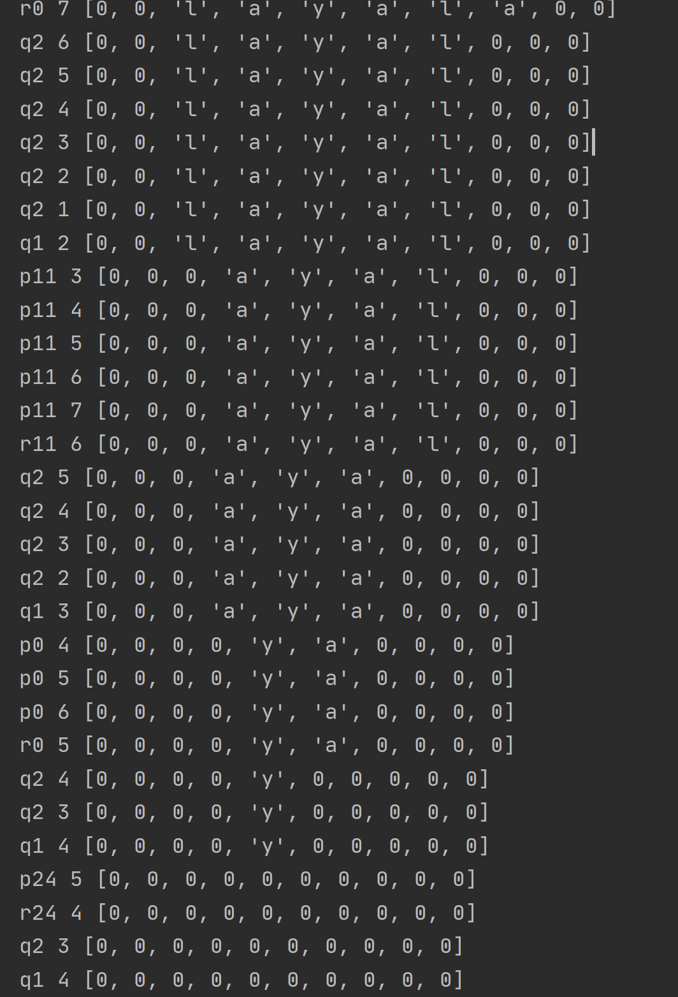

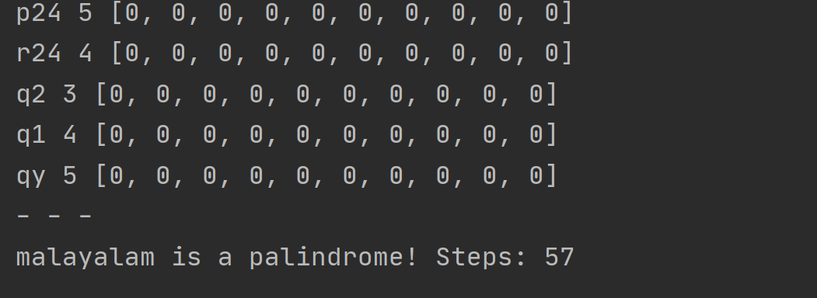

**NOT A PALINDROME**

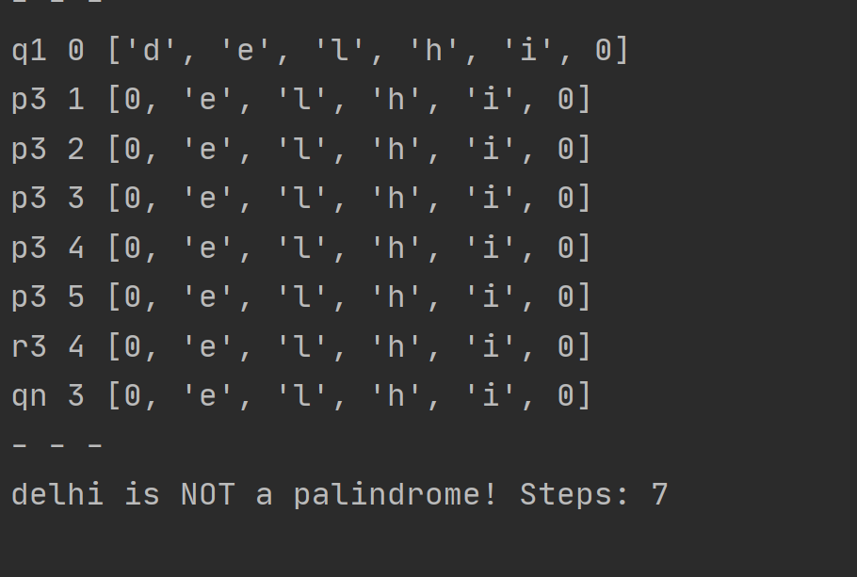

Tape head starts off at the first character and moves on till the end. As soon as comparison is not successful the program terminates, giving a output , “NOT A PALINDROME !”.

**Technologies Used:-**

Python 3.0

PyCharm IDE

**References**

[www.tutorialspoint.com](http://www.tutorialspoint.com)

[www.youtube.com/neso-academy](http://www.youtube.com/neso-academy)

[www.wikipedia.com](http://www.wikipedia.com)

**Conclusion**

We were successfully able to simulate the working of a turing machine step by step to check whether a given string is a palindrome.